New York’s Medicaid Program is Key to Helping
Address the Opioid Epidemic

Medicaid and Medicaid Expansion through the ACA are vital allies in the battle against increased overdoses, hospitalizations and deaths related to opioids in New York. We urge legislators to sustain funding for Medicaid and reject any proposed cuts to the program to effectively address the opioid crisis, especially among low-income New Yorkers.

New York is Being Affected by Opioids and Fentanyl More Intensely Than Most States
- New York’s opioid overdose rate has increased for the past 6 years and is higher than the U.S. average.
- New York’s opioid-related hospitalization rate is 60% higher than the national rate and has remained relatively consistent over the past 10 years.
- New York has consistently had a lower opioid-prescriber rate then the U.S. average, yet has experienced a sharper increase of fatal poisoning
by all opioids from 2013 to 2015 that has outpaced the national average.²

Medicaid and Medicaid Expansion Are Fighting the Opioid Epidemic
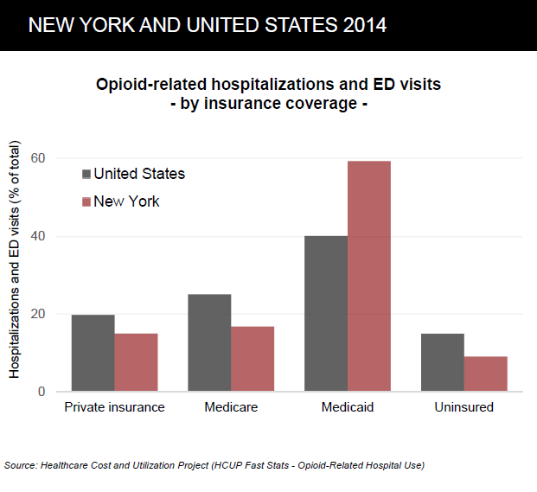
- Medicaid funds services that support recovery from opioid use disorder including detoxification, individual and group therapy, medication assisted treatment, and supportive housing.
- 60% of patients hospitalized or visiting the emergency room in New York due to opioids have Medicaid coverage, which is much higher than the national average of 40%.²
  - The rate of opioid-related hospital visits in New York has doubled since 2005.²
- Less than 10% of patients in New York with opioid-related emergency room visits are uninsured, compared with the national average of over 15%.²

While significant progress has been made in increasing access to community based addictions services, through the implementation of Certified Community Behavioral Health Clinics and other initiatives, obtaining comprehensive mental health and substance use treatment remains a challenge in New York. Medicaid plays a crucial role in connecting individuals with opioid use disorders to services.

Behavioral health services save money by keeping New Yorkers with mental health and substance use disorders out of emergency rooms, jails and shelters. New Yorkers rely on Medicaid as a source of treatment, making the preservation of Medicaid funding and services critical. Significant investments to support additional prevention, treatment & recovery programming statewide are needed to ensure all who seek services can access them when and where they need them.

Heun-Johnson et al. (2018). The cost of mental illness: New York facts and figures. USC Schaeffer Center. Retrieved from https://www.bhecon.org/wp-content/uploads/2018/01/NY-Chartbook-2018_FINAL.pdf
Ibid.

