Support Mental Health and Criminal Justice Interventions to Lower Health Care Costs in the United States
Individuals living with serious mental illness (SMI) or substance use disorders (SUD) are overrepresented in the criminal justice system, typically for non-violent crimes or low-level offenses, suggesting that lack of access to treatment for SMI/SUD is a factor in incarceration risk. Upon release, many individuals lose access to behavioral health services, which increases the likelihood of a re-arrest. The criminal justice system has become the largest de facto mental health and addiction treatment provider in United States due to an underfunded and overburdened safety net, but prisons and jails are often poorly equipped to address SMI or SUD, leading to increased costs for states and counties. Community-based treatment lowers the chances of reincarceration, decreases the burden on jails and prisons to provide mental health services, and improves outcomes for these individuals by providing evidence-based treatment that can help them avoid arrest due to their condition.

Understanding the Nexus of Behavioral Health and Criminal Justice
In 2012, jails and prisons housed 10 times as many persons with SMI than state hospitals, highlighting that individuals with SMI are more likely to encounter the justice system than receive behavioral health services.
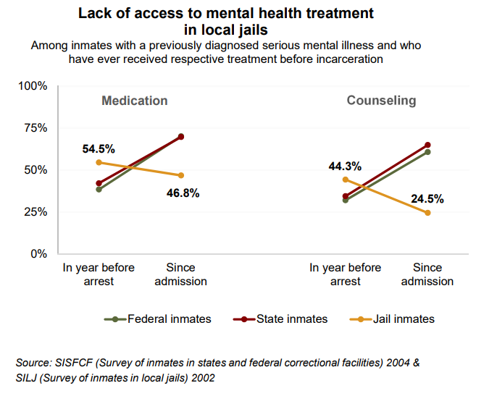
- Individuals living with serious psychological distress (SPD) are three times more likely to be arrested or on parole in the past year, largely for non-violent offenses.
- Prisoners with SMI generally have longer stays as they are less likely to make bail and have difficulty obtaining reductions in their sentences.
- Data shows that while state and federal prisons usually have more resources to provide behavioral health treatment to prisoners who were not receiving services before incarceration, they are intensely overburdened. Local jails are even less able to provide treatment for mental illness as shown in the graphic.
- Inmates are seven times more likely than the general population to have a lifetime instance of SUD.
Investing in Community-Based Mental Health and Addiction Services Can Decrease Costs of Incarceration
Diversion programs, re-entry services, mental health courts and partnerships between behavioral health providers and local law enforcement are decreasing recidivism and reducing the amount of time police officers spend in the emergency room. When individuals with mental illness do receive the services and supports they need, their quality of life is improved and the burden on the criminal justice system is reduced.
- Individuals living with SMI who have consistent access to high-quality treatment and adhere to their medications are much less likely to encounter the criminal justice system. Often, their treatment costs are shared with the federal government through Medicaid, whereas criminal justice costs are borne by states and counties.
- Every dollar invested in substance use disorder treatment with criminal justice-involved clients yields a return of $4 to $7 in reduced crime, criminal justice costs and theft.
The bottom line: Having an untreated serious mental illness should not be a jail sentence, and prisons and jails should not be the primary providers of behavioral health services. It is more economical to divert individuals with SMI/SUD from the criminal justice system, provide re-entry services like targeted case management and establish mental health courts than to incarcerate individuals who actually need treatment. Investing in these types of programs not only saves money that would otherwise be spent on incarceration and hospitalization, but also lessens the burden that dealing with SMI and SUD places on the criminal justice system.

Torrey, E. F., Zdanowicz, M. T., Kennard, A. D., Lamb, H. R., Eslinger, D. F., Biasotti, M. C., & Fuller, D. A. (2014). The Treatment of Persons with Mental Illness in Prisons and Jails: A State Survey. Retrieved from http://www.treatmentadvocacycenter.org/storage/documents/treatment-behind-bars/treatment-behind-bars.pdf
Serious psychological distress (SPD) includes mental health problems that cause some level of impairment in one’s life and require treatment.
Heun-Johnson, H., Menchine, M., Goldman, D., Seabury, S. (2018). The Cost of Mental Illness: New York Facts and Figures. Retrieved from https://www.bhecon.org/wp-content/uploads/2018/01/NY-Chartbook-2018_FINAL.pdf
Torrey et al., The Treatment of Persons with Mental Illness in Prisons and Jails. (See footnote 1)
The Pew Charitable Trusts and the John D. and Catherine T. MacArthur Foundation. (2014). State Prison Health Care Spending: An examination. Retrieved from http://www.pewtrusts.org/~/media/assets/2014/07/stateprisonhealthcarespendingreport.pdf
Robertson, A. G., Swanson, J. W., Van Dorn, R. A., Swartz, M. S. (2014). Economic Grand Rounds: Treatment Participation and Medication Adherence: Effects on Criminal Justice Costs of Persons with Mental Illness. Psychiatric Services, 65(10). Retrieved from https://doi-org.proxygw.wrlc.org/10.1176/appi.ps.201400247
The National Institute on Drug Abuse. (1999). Principles of Drug Addiction Treatment: A Research-Based Guide. Retrieved from https://www.drugabuse.gov/sites/default/files/podat_1.pdf

