Invest in Community Behavioral Health, Diversion Programs and Reentry Services
to Save Corrections Dollars

People living with serious mental illness (SMI) or substance use disorders (SUD) are overrepresented in the criminal justice system for non-violent crimes or low-level offenses, suggesting that lack of access to treatment for SMI/SUD is a factor in incarceration risk. Upon release, many individuals lose access to behavioral health services which increases the likelihood of a re-arrest. The overall cost of incarceration of the nearly 9,000 prisoners with SMI in the state of New York exceeds $558 million per year.

Understanding the Nexus of Behavioral Health and Criminal Justice
- In the U.S., an individual who has had serious psychological distress in the past year is three times more likely to be arrested, largely for non-violent offenses. ¹
- In the U.S. in 2012, jails and prisons housed 10 times the number of individuals living with mental illness than did state hospitals, highlighting that individuals with SMI are more likely to encounter the criminal justice system than receive behavioral health services.
- Inmates arrested are seven times more likely to have a substance use disorder.
  - Every dollar invested in corrections substance use disorder treatment yields a return of $4 to $7 in reduced crime, criminal justice costs, and theft.
New York Has Opportunities to Improve and Save Costs
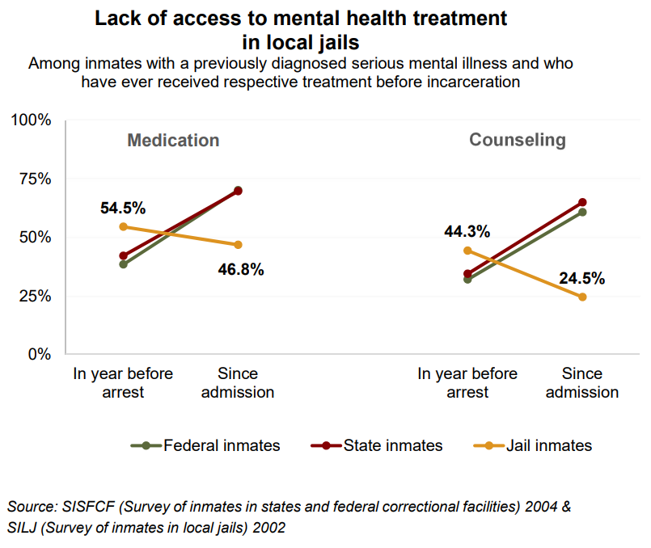
- 17 percent of inmates in New York state prisons have previously been diagnosed with a SMI, which is less than the national average of 22 percent.¹
- At Riker’s Island, an inmate’s average stay is 42 days, but for individuals with SMI it is 215 days. Lack of access to comprehensive behavioral health services can result in a longer stay.
- 15 percent of New York State inmates have depressive disorder, leaving them at increased risk for suicidal behavior.
Whereas state and federal prisons generally have more resources to provide behavioral health treatment to prisoners who were not receiving services before incarceration, they are intensely overburdened. Local jails are even less able to provide treatment for mental illness as shown in the graphic.

Behavioral health treatment progress is lost when individuals enter the CJ system. In addition to continuing to support critical diversion and re-entry programs across the state, lawmakers should also be supporting full funding for Close to Home and Raise the Age implementation to ensure that young people who are criminally involved have opportunities to access needed services including behavioral health programming to reduce recidivism and increase positive community integration.

Heun-Johnson et al. (2018). The cost of mental illness: New York facts and figures. USC Schaeffer Center. Available: https://www.bhecon.org/wp-content/uploads/2018/01/NY-Chartbook-2018_FINAL.pdf
Torrey et al. (2014). The treatment of persons with mental illness in prisons and jails. http://www.treatmentadvocacycenter.org/storage/documents/treatment-behind-bars/treatment-behind-bars.pdf
Pew Charitable Trusts. (2014). State prison health care spending. http://www.pewtrusts.org/~/media/assets/2014/07/stateprisonhealthcarespendingreport.pdf
NIH. (1999). Principles of drug addiction treatment. https://www.drugabuse.gov/sites/default/files/podat_1.pdf
Pew Charitable Trusts. (2014). State prison health care spending. http://www.pewtrusts.org/~/media/assets/2014/07/stateprisonhealthcarespendingreport.pdf

