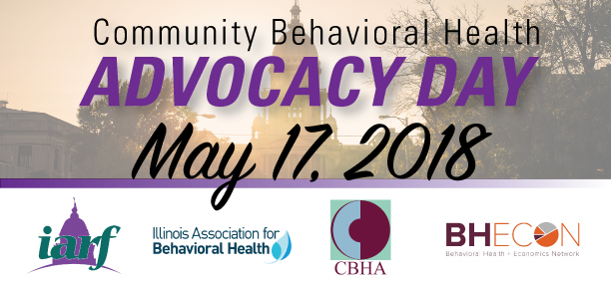

Welcome to Behavioral Health Advocacy Day!

9:00 - 9:30 a.m.
Registration

9:30 - 9:40 a.m.
Welcome and Opening Remarks
Dennis Alexander
Director, State Policy & Advocacy - National Council for Behavioral Health

9:40 - 10:15 a.m.
Federal Landscape for Behavioral Health
Michael Petruzzelli
Manager, Policy & Advocacy - National Council for Behavioral Health

10:15 - 10:45 a.m.
Illinois’ 1115 Waiver
Teresa Hursey
Administrator of Medical Programs - IL Dept. of Healthcare and Family Services

10:45 - 11:15 a.m.
Coffee Break

11:15 - 11:45 a.m.
The Cost of Mental Illness: Illinois Facts and Figures
Seth Seabury, PhD
Director, Keck-Schaeffer Initiative for Population Health

11:45 a.m. - 12:15 p.m.
Advocacy at the Capitol - the “Ask”
IARF, IABH, and CBHA

12:15 - 12:30 p.m.
Closing Remarks - Break for Lunch!
IARF, IABH, and CBHA

